

MATHEMATICS
Specialist Units 3 & 4

Test 5 – Applications of Differentiation and Differential Equations

Chapters 12 and 16
Semester 2 2017

Section Two – Calculator Assumed

Time allowed for this section
Working time for this section: 40 minutes
Marks available: 38 marks

Material required/recommended for this section

To be provided by the supervisor
This Question/Answer booklet
Formula sheet

To be provided by the candidate
Standard items: pens, pencils, pencil sharpener, eraser, correction fluid, ruler, highlighters

Special items: drawing instruments, templates, notes on one unfolded sheet of A4 paper, and up to three calculators satisfying the conditions set by the Curriculum Council for this course.

Important note to candidates
No other items may be used in this section of the examination. It is your responsibility to ensure that you do not have any unauthorised notes or other items of a non-personal nature in the examination room. If you have any unauthorised material with you, hand it to the supervisor before reading any further.
- (8 marks)
A particle P is projected from the top of a cliff of height 100 m. Define x and y metres as the horizontal and vertical distance travelled by the particle measured from the base of the cliff after t seconds.
Its equation of motion at any time t seconds is given by $\frac{dx}{dt}=20\sqrt{2}$ and $\frac{dy}{dt}=20\sqrt{2}-10t$.

- Determine the equation of the horizontal distance travelled by the particle after t seconds. [1]

- Determine the equation of the vertical distance travelled by the particle after t seconds. [2]

- The equation of the path of P is given by $y=ax^{2}+bx+c$. Determine a, b and c. [3]

- Determine, using calculus methods, the approximate change in the vertical distance when the horizontal distance changes from 10m to 10.1m. [2]

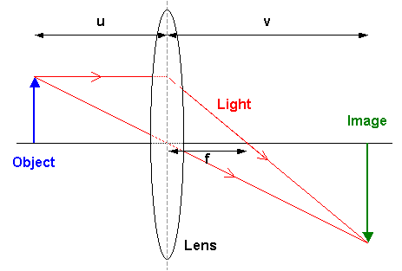
- (4 marks)
When an object is at a distance of u cm from a lens of focal length, f = 20 cm, an image is created at a distance of v cm from the lens.
The variables are related by the formula $\frac{1}{20}=\frac{1}{u}+\frac{1}{v}$

An object is moving with a constant speed of 2 cm/s
towards the lens. At the instant when the image is
30 cm from the lens, in what direction and with
what speed is the image moving?

- (3 marks)

A leaking water tank initially contains water to a depth of 1.6m. The depth of water,
h cm, is decreasing at a rate (in cm/s) equal to one tenth of the depth of the water in the tank.

- Write a differential equation that describes the rate of change of the depth of the water in relation to the depth. [1]

- Determine the solution to the differential equation and calculate, to the nearest tenth of a second, the time taken for the depth to decrease to just 5 cm. [2]

- (8 marks)
The motion of a body moving in a straight line is modelled by the differential equation $\frac{dx}{dt}=3+4x$, where x metres is the displacement from a fixed point at time t seconds for
t ≥ 0. After 1 second the body is 2m to the right of the origin.

- What is the acceleration of the body when t = 1s? [3]

- Show that the displacement is given by $x=\frac{11e^{4t-4}-3}{4}$. [5]

- (9 marks)
The population P of a colony of marsupials at a remote island is currently 20. The colony’s expected growth rate is given by $\frac{dP}{dt}=0.1P(1-\frac{P}{200})$, where t is in years.

- By separation of variables and use of partial fractions express P as a function of t, in the form $P=\frac{A}{1+Be^{-kt}}$ [7]

- Determine the time it takes for the population to reach half its limiting value. [2]

- (6 marks)
A light is positioned at the top of a vertical post 12m high. A small ball is dropped vertically from the same height as the light but at a point 4m away. The vertical distance travelled by the ball t seconds after release is given by $4.9t^{2}$.

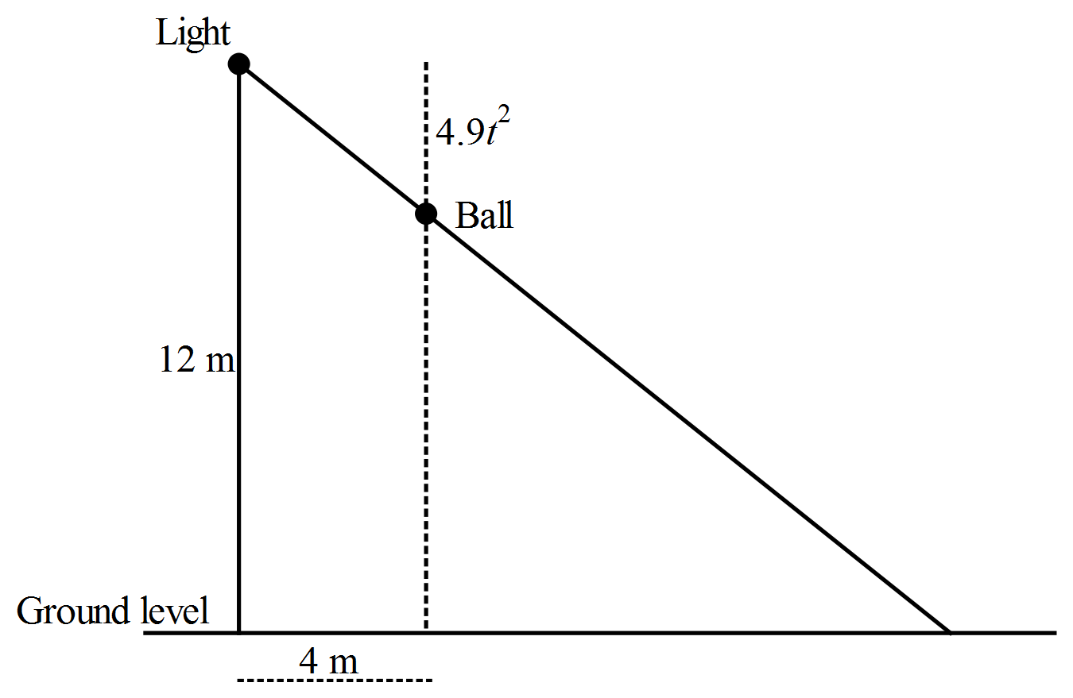

How fast is the shadow of the ball moving along the horizontal ground half a second after the ball is dropped?

End of Section Two
This page has intentionally been left blank
You may use this space to extend or re-attempt an answer to a question or questions and should you do so then number the question(s) attempted and cross out any previous unwanted working.

